**Unveiling the Virtual Classroom: An In-depth Analysis of the Online Education System**

1. **Problem Understanding**
   1. **Specify the business problem**

Online classes and technology have emerged as a superhero during the lockdown days. We have all been under house arrest but are still connected with the world of education. Due to the lockdown, students have not been able to stay connected with the outer world and the lack of exposure is evident. The only reprieve for the students’ mental well-being has been the transition to online classes. Teachers made sure that the learning for students was not compromised, so they took a great leap forward to find solutions and create new learning environments for their students to ensure that learning never stops. With the rapid advancements in technology and the widespread availability of internet access, online education has gained significant popularity in recent years.

This project aims to delve deep into the various aspects of online education, examining its strengths, weaknesses, opportunities, and challenges. The outcomes of this project will provide valuable insights for educational institutions, policymakers, and online learning platforms to enhance the effectiveness and accessibility of online education. This analysis of the online education system aims to contribute to the ongoing dialogue on the future of education and help shape a more inclusive, engaging, and effective learning environment in the digital age.

* 1. **Business requirements**

The project requires student and teacher surveys, understanding student needs, and having an efficient feedback system. There is a need to update the content that is being taught to students based on the feedback. These requirements are necessary to ensure that students are able to find it easy to adjust with online education / e-learning. The requirements vary bases on the geographic location of the students. Some of the key business requirements for online education are listed below.

* **Market Research and Target Audience Analysis:**
  + Identify your target audience, their needs, preferences, and pain points.
  + Analyze the competitive landscape to understand market trends and potential gaps.
* **Clear Educational Objectives:**
  + Define clear learning objectives for your courses or programs.
  + Ensure alignment between educational goals and business objectives.
* **Content Development and Quality Assurance:**
  + Create high-quality educational content that is engaging and relevant.
  + Implement a rigorous quality assurance process to maintain content standards.
* **Technology Infrastructure:**
  + Choose a reliable Learning Management System (LMS) or e-learning platform.
  + Ensure scalability to accommodate growing user numbers and content.
* **User-Friendly Interface and User Experience:**
  + Design an intuitive and user-friendly interface for easy navigation.
  + Prioritize responsive design for mobile and tablet devices.
* **Monetization Strategy:**
  + Determine your pricing model (subscription, pay-per-course, freemium, etc.).
  + Implement secure payment processing and billing systems.
* **Marketing and Promotion:**
  + Develop a marketing strategy to reach your target audience.
  + Utilize digital marketing channels, social media, and content marketing.
* **Customer Support and Engagement:**
  + Provide robust customer support for technical and educational queries.
  + Foster an online community for learner interaction and engagement.
* **Data Analytics and Reporting:**
  + Implement analytics tools to track user behavior and course performance.
  + Use data to make informed decisions and improve course offerings.
* **Compliance and Accreditation (if applicable):**
  + Ensure compliance with relevant educational regulations and standards.
  + Seek accreditation from relevant authorities if necessary.
* **Security and Privacy:**
  + Implement strong security measures to protect user data and content.
  + Comply with data privacy laws and regulations, such as GDPR or HIPAA.
* **Scalability and Future Growth:**
  + Plan for scalability to accommodate a growing user base.
  + Consider expansion into new markets or offering additional courses.
* **Content Licensing and Intellectual Property:**
  + Address copyright and licensing issues for third-party content.
  + Protect your intellectual property rights for original content.
* **Feedback and Continuous Improvement:**
  + Collect feedback from users and instructors to enhance the platform.
  + Continuously update and improve content and features based on feedback.
* **Legal and Financial Considerations:**
  + Establish clear terms of service and refund policies.
  + Budget for operational costs, including content creation and platform maintenance.
* **Accessibility and Inclusivity:**
  + Ensure that the platform is accessible to individuals with disabilities.
  + Promote inclusivity and diversity in course content and materials.
* **Partnerships and Collaborations:**
  + Explore partnerships with educational institutions, content providers, or industry experts.
  + Collaborate with subject matter experts for course development.
* **Feedback and Review Mechanisms:**
  + Implement mechanisms for course reviews and evaluations.
  + Gather feedback from instructors and learners to improve courses.
* **Legal and Compliance Considerations:**
  + Adhere to copyright and intellectual property laws.
  + Comply with data protection and privacy regulations, such as GDPR or COPPA.
* **Business Continuity and Disaster Recovery:**
  + Develop plans to ensure the platform's availability in case of technical failures or disasters.

Successful online education platforms require a holistic approach that combines educational expertise with effective business strategies to meet the needs of learners and achieve sustainable growth.

Top of Form

* 1. **Literature Survey**

Rajasekaran and Arulchelvan (2015) studied “Effectiveness of Visuals in E-Learning on Media Communication Courses” in Tamilnadu. The Objectives were to find out the effectiveness of visuals in media communication courses, to find significant role played with

* Factors affecting the e-learning, Perceptions and Readiness of students about e-learning
* Studies Conducted in India • Studies Conducted in Abroad
* Development and Validation of E-content/ E-learning packages
* Studies Conducted in India • Studies Conducted in Abroad
* Blended Learning Experiences in Higher Education art and design.

The sample of the study consisted of 415 student from bachelor degree courses (art, architecture and media) Anna University and other colleges offering same courses. Random sampling method was used for sampling. Research Design was Survey. The Tool used for Data collection was self-administered questionnaire. The major findings of the study revealed that visuals in stories were adding interest and improved learning was the most important factor on awareness on e–learning content, followed by e-learning used for updating knowledge and user friendly. Learning created interest to explore the learning ,Like the idea of learning with 3D graphics and animation using in a computer than sitting in a classroom with a teacher and book, e-learning accessible at any time and any place and so on. The least factor was e-learning was expensive than other learning followed by Solve the problems in a better way compared to classroom assignments, Visual learning was better than the face to face class, Easy to remember the e-learning content and so on. Video gave overall input about the content along with audio was the most important factor on Effects of various Types of Visuals In e-learning Content Design of Students on Video, followed by Feel of reality was high in video than the other forms of visuals . The least factor was stronger colours disturbed the learner to learn followed by Text + audio were highly supported by visuals for effective learning. The Impact of visuals among Students before showing the various types of visuals in media communication and design principles on elearning content was 48.9 percentage. The Impact of visuals among Students after showing the various Types of visuals in media communication and design principles on e- learning content was 70.2 percentage. Visual based e-learning method made the students more understanding of the media, art and design subjects than traditional face-to-face teaching method. Visuals based e-learning could create easy understanding, focus on learning, retention level, and higher score in the examinations among the students were highly possible.

Sharma and Hardia (2013) carried out a research on “-Measuring Level of Usage of Elearning amongst Students Pursuing Higher Education. The Objectives of the Study were to identify the factors affecting the level of usage of e-learning amongst students of higher learning and to study the effect of demographics on the factors affecting the level of usage of e-learning amongst students of higher learning. Data was collected using a self-prepared questionnaire. The questionnaire was sent to 400 students pursing higher education in Indore and nearby city. A total of 341 questionnaires were found to be suitable for the analysis. In order to study first objective factor analysis was carried out. Factor analysis was conducted on the survey data using SPSS to establish the factor structure of level of usage of e-learning amongst students of higher learning. Factors were found to be significant were

* Comfort level with technology
* Group Learning
* Disciplined Explorer.

Based on the results above gender, qualification and educational background was not found to be significant in the level of usage of e learning for students of higher education. However age was found to be significantly affecting the level of usage of e-learning for students of higher education. Further was observed that work experience was not found to be significant for comfort level with technology and learning using technology but was found to be significant with group learning.

Sood and Singh (2014) studied on “e-learning: Gender analysis in higher education in North India”. The study was aimed to analyse the genders’ interest in e-Learning in higher education in the northern part of India. A questionnaire survey designed for the purpose gathered information on students’ participation and opinions about the use of e-Learning in higher education. The survey was conducted on a group of 392 people involved in higher education in Chandigarh (northern part of India) and surrounding areas. The group was a heterogeneous one and consisted of students in the fields related to Information Technology at the college and university level. The students targeted were the ones who were enrolled in different streams (related only to the field of IT) at under graduate and post graduate levels for studying in various colleges as well as in the university affiliating these colleges. The analysis of the results clearly indicated that the e-learning patterns were not gender sensitive as far as the web-based learning style was concerned. Similarly, it was found that there was no significant gender sensitivity in the area of interests in software project management. But as far as the issues of ‘knowledge about the typical patterns observed in software projects’ was concerned, the various parameters have been found to be significantly gender sensitive.

Jaiswal (2013) conducted a study on “Current Status of e-Learning in Indian Higher Education: A Case Study of U.P”. The study was conducted to find out the current status of elearning in higher education. The objectives of the Study were to study current status of elearning in Universities and their affiliated Aided colleges of U.P. (India) and to study teachers’ and students’ perception towards e-learning. Thus, in order to study this objective 2919 teachers (839 teachers from professional courses and 2080 teachers from non-professional courses) and 7717 students (4512 students from professional courses and 3205 from nonprofessional courses at UG & PG levels) were selected as a sample for the present study. Professional courses were consisted of BBA, BCA, B.Tech., B.Pharma, BFA, LLB, B.Ed., M.Ed., MBA, MCA, MFA, MSW, M.SC.(Biotech.), M.Sc.(Microbiology), and PGDCA whereas non-professional courses were comprised of B.A., B.Sc., B.Com., B.Sc.(Ag.), MA, M.Sc., M.Com, M.Sc.(Ag.) were selected as a sample from the eleven state universities of U.P. for the study. Self-developed tools on e-learning covering above objectives were used in the study to collect the data from teachers and students. It was found that below average number of professional courses’ teachers in higher education were using e-learning mode whereas only a few non-professional courses’ teachers were using e-learning mode. There were three modes of e-learning viz. online mode, hybrid/blended mode and e-enhancement mode but only enhancement mode was being used by the professional and non-professional courses’ teachers in Indian higher education. The major findings of the study were as follows:

* + - Below average number of professional courses’ teachers in higher education is using e-learning mode. Only a few non-professional courses’ teachers are using e-learning mode. There are three modes of elearning viz. online mode, hybrid/blended mode and enhancement mode but only eenhancement mode is being used presently by the professional and non-professional courses’ teachers in higher education. Teachers also admitted the benefits of integration of e-learning in their pedagogy. The study also found that majority of teachers is using e-learning from the last five years. Also the majority of students and teachers are completely satisfied with elearning mode.
    - Currently being used features of e-learning are providing general information, study notes and interaction through e-mail, guiding student to web resources, and to some extent assignment handling and feedback; virtual class room facility. Further, the features of elearning which may be most useful according to teachers are providing general information, study material, links to web resources, online discussion, online tutor support, virtual classroom facility, VLE for assessment methods and e-LMS.
    - Majority of teachers are in favour of use of various aspects of e-learning in future viz. mlearning, podcasting and vodcasting, intelligent tutoring system, educational simulation and games and educational blogging.
    - According to teachers the most benefitted aspects of teaching-learning by introducing elearning are delivery of teaching-learning, development of the content, interaction, management and resources for teaching-learning whereas the least benefitted aspects were assessment and student support. Greatest benefits of introducing e-learning from student perspective are self-pacing, communication and feedback, deeper knowledge, helps in building specific skills, helps in targeting specific weaknesses of students, and increase in accessibility to content and tutor.
    - It was found that almost half of the teachers and only a few students have access to UGC Infonet e-journals in their library although their teachers admitted that near about average students have access to e-journals. Majority of the students and teachers are satisfied with the e-journals but some teachers and students also reported problems in accessing ejournals provided by UGC-Infonet such as low access speed.
    - Almost half of the students reported that utilization of traditional library has been decreased by 20 percent because of digital library. More than average number of students reported about 20 percent decrease in use of other modes of learning because of elearning.
    - The major motives for introducing e-learning for professional courses’ teachers are meeting individual needs, encouragement of learner autonomy, development of life-long learning skills, self-pacing, enrichment of learning resources, improving student’s experiences. Similarly, major motives for non-professional courses’ teachers were encouragement of learner autonomy, development of life-long learning skills, self-pacing and improving student’s experiences.

Lakshmi (2012) carried out a research titled “A study on E-learning in Gujarat”. The objectives were to study the e-learning forms in adopted in higher education institution in Gujarat to infrastructure facilities available in higher education institution in Gujarat and to study the opinions of students, faculties and lab administrators regarding e-learning practices being adopted in higher education institutions of Gujarat regarding concept of e-learning, use of e-learning tools and Future scope of e-learning. The sample of the study consisted of 83 faculties, 153 students and 12 lab administrators using online learning fully or in blended mode from 22 Higher Education Intuitions. Research was carried out using Survey design. Tool Used for Data collection Questionnaire. Major findings of the study revealed that most of the faculties in higher education institutions had individual personal computers with internet connection, with higher bandwidth for them in their staff rooms. Only few institutions were using CMS/LMS for providing e-learning practices and When it came to blended form of elearning approach, most of the institutions were using the basic e-learning practices lie intranet and e-mail while the practices like blogs, video conferencing, chats, virtual classrooms were adopted at a very minimal level in the institutions which were adopting the e-learning practices and Many higher educational institutions were making use of institutional website to adopt either blended approach of e-learning or fully online approach. Selected institutions were offering any self-paced courses in module formats in various areas of studies either through institutional websites or through their tele-learning centres. Some of the initiatives many institutions uploaded their courseware, recorded video sessions, interactive tele-conferencing sessions, online counselling sessions, sample question papers, question banks, online assignments, lab manuals on to their website. The most common available facilities of elearning were online study material, online syllabus while assignment feedback, tests or quizzes, open forums, web seminars and digital libraries were the least available e-learning facilities. It was observed that most of the higher education institutions were using the elearning practices since last three years and in very few institutions it was mandatory for the faculties to use e-learning practices in their teaching –learning, evaluation and other aspects. Both students and faculties felt that the e-learning practices adopted by the institutions were at very basic level and hence they did not need any special guidance in this regard. Majority of stakeholders were satisfied with regard to the e-learning practices being adopted in the institutions. According to the respondents gender did not appear to moderate the response of students in e-learning mode and academically well prepared students respond more positively to e-learning practices of the institution than academically less prepared students. Regarding the benefits of e-learning, the stakeholders felt that access to information related to the course content becomes easy and fast in the e-learning platform and further it was easy to reach more students in less time. They all almost equally felt that e-learning platform provides the scope for learning at own pace, at any time. However, both faculties and students expressed that elearning platform was not of that help in maintaining transparency in the system. On the part of the faculties, they felt that providing additional information regarding the course becomes easy in e-learning.

Nachimuthu (2010) conducted a study titled “Identifying the usability of e-learning resources in teacher education of India”. The objective of the study was to identify the usability of elearning resources in teacher education of India. The sample of the study consisted of 17 College of Education 115 B.Ed. Students in Salem District of Tamilnadu. Convenience sampling method was used as sampling pattern. The research designed used was Survey. Tool used for data collection was Questionnaire. Major Findings of the study were that all the institutions were having at least five computer peripherals with 70 per cent Air conditioned facilities in their ICT laboratories. Majority of B.Ed. college Trainees and their colloquies were already taking actions regarding some of the accepted ways of use of computers in their regular classrooms (32.0), however they were not prepared to sacrifice their personal comfort for using e-books (in total 45%), they have strong reasons for that. The College of Education trainees were using the physical books handling (86.2) rather than the e-books were also evidenced that, they were either not having enough time to use e-books or entry in the computer labs.

* 1. **Social or Business Impact**

Understanding the social impact of e-learning, including its pros and cons, is crucial for improving this mode of education for future generations. E-learning has evolved significantly, especially in recent years, and its social implications have become more pronounced.

**Pros of E-Learning:**

1. Accessibility: E-learning breaks down geographical barriers, making education accessible to individuals regardless of their location. This inclusivity is particularly beneficial for students in remote areas or those with physical disabilities.
2. Flexibility: E-learning offers flexibility in terms of scheduling and pacing. Learners can access materials at their convenience, allowing them to balance education with work, family, or other commitments.
3. Cost-Effective: Online courses often cost less than traditional in-person education, as there are no expenses for commuting, housing, or physical classroom facilities.
4. Personalization: E-learning platforms can tailor content to individual learning styles and pace, potentially leading to more effective learning experiences.
5. Global Learning Communities: E-learners have the opportunity to connect with peers and instructors from around the world, fostering diverse and inclusive learning environments.

**Cons of E-Learning:**

1. Digital Divide: Not all learners have access to the necessary technology and internet connectivity, exacerbating existing inequalities in education.
2. Lack of Social Interaction: E-learning can be isolating, as it often lacks the face-to-face interaction found in traditional classrooms. This may lead to feelings of loneliness and decreased motivation.
3. Self-Motivation: E-learning requires a higher level of self-discipline and motivation. Some students may struggle with time management and staying engaged.
4. Quality Assurance: Ensuring the quality of online courses can be challenging. There is a risk of subpar content and inadequate assessment methods.
5. Limited Practical Experience: Some fields, such as hands-on sciences or trades, require practical, hands-on experience that e-learning cannot fully replicate.

**Improving E-Learning for Future Generations:**

1. Address the Digital Divide: Governments and educational institutions should invest in infrastructure and provide devices and internet access to underserved communities to bridge the digital divide.
2. Enhance Social Interaction: Incorporate tools for real-time collaboration, discussion forums, and group projects to facilitate social interaction and a sense of community among online learners.
3. Support and Training: Offer resources and training to help students develop effective online learning skills, time management, and self-motivation.
4. Quality Control: Ensure rigorous quality assurance mechanisms, including accreditation standards, peer reviews, and regular updates to course content.
5. Blended Learning: Implement blended learning models that combine online and in-person instruction, allowing for a more balanced and holistic educational experience.
6. Lifelong Learning: Promote the concept of lifelong learning, where individuals continuously acquire new skills and knowledge throughout their lives, adapting to changing job markets and technologies.
7. Feedback and Assessment: Develop innovative assessment methods that go beyond traditional exams to evaluate students' real-world problem-solving abilities and critical thinking skills.
8. Cultural Sensitivity: Recognize and address cultural and linguistic differences in e-learning materials and ensure inclusivity in course content.
9. Research and Innovation: Invest in research on e-learning effectiveness and innovative technologies to enhance the learning experience continually.
10. Mental Health Support: Offer mental health resources and support services to address potential feelings of isolation and stress associated with online learning.

In summary, e-learning has the potential to revolutionize education by increasing access and flexibility. However, it also presents challenges related to accessibility, engagement, and quality. To make e-learning better for future generations, stakeholders must collaborate to address these issues and ensure that online education is equitable, engaging, and effective for all learners.

1. **Data Collection**

Data collection is the process of gathering and measuring information on variables of interest, in an established systematic fashion that enables one to answer stated research questions, test hypotheses, and evaluate outcomes and generate insights from the data.

* 1. **Collect the dataset**

The dataset contains the following attributes with 1033 instances.

* Gender: Gender of the student
* Home Location: Rural or Urban.
* Level of Education : UG, PG or school
* Age : age of the student
* Number of subjects :
* Device Type Used : device used to attend the online classes
* Economic status :  economic status of the family
* Internet facility in your locality
* Are you involved on any sports
* Family Size
* Do elderly people monitor you ?.
* Study Time(hours)
* Sleep time (hours)
* Time spent on social media(hours)
* Interested in gaming ?
* Have a separate room for studying ?
* Engaged in group studies ?
* Average marks scored before pandemic in traditional classroom
* Your interaction in online mode
* Clearing doubts with faculties online ?
* Interested in ?
* Performance in online
* Your level of satisfaction in online education
  1. **Connect data with IBM cognos**

Login to IBM Cognos, Launch IBM Cognos, now go to theprepare data section, click on upload option and upload the csv file

Step-1: <https://login.ibm.com/authsvc/mtfim/sps/authsvc?PolicyId=urn:ibm:security:authentication:asf:basicldapuser&Target=https%3A%2F%2Flogin.ibm.com%2Foidc%2Fendpoint%2Fdefault%2Fauthorize%3FqsId%3Dd49cb291-375a-44ad-bfb4-bbbdfce5d7b5%26client_id%3DY2ExMTdkN2QtYThmMS00>

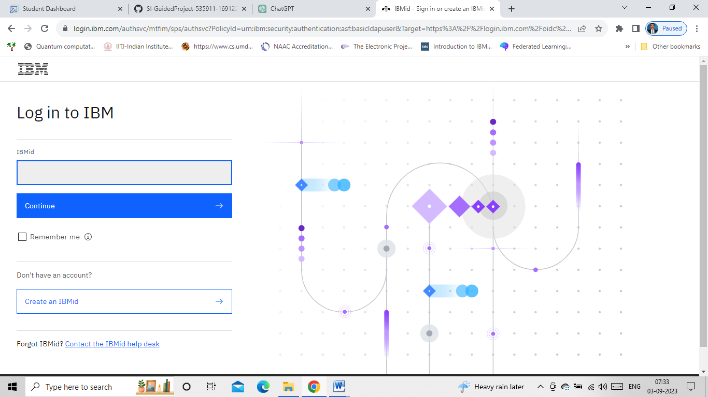

Step-2: Enter the loginID and the password. The following screens pops up.

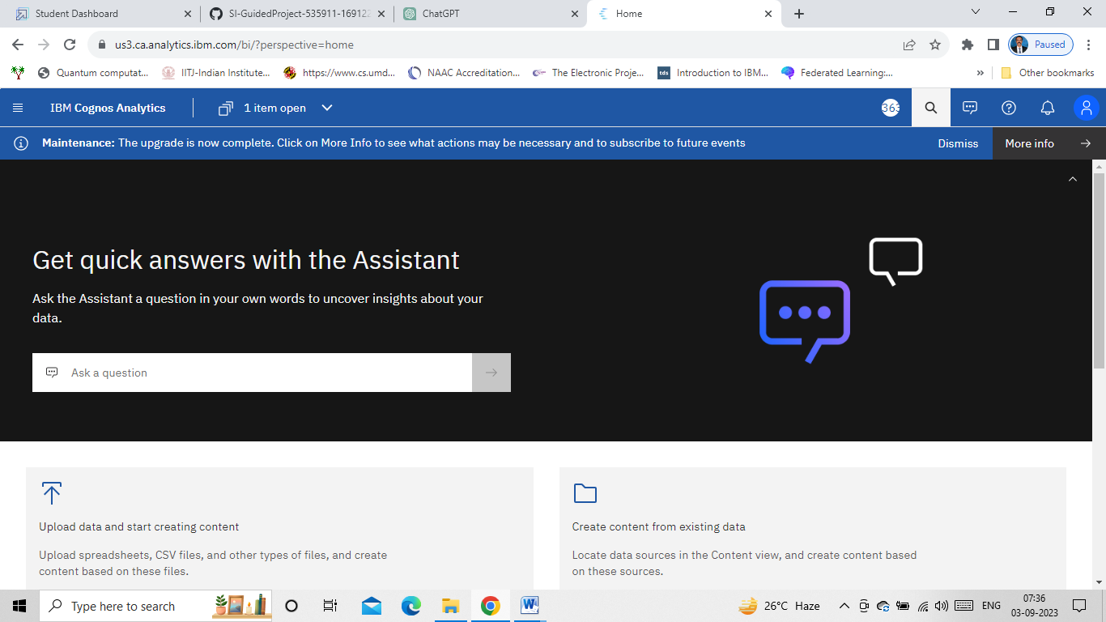

Step-3: Upload the dataset

1. **Data Preparation**

Preparing the data for visualization involves cleaning the data to remove irrelevant or missing data, transforming the data into a format that can be easily visualized, exploring the data to identify patterns and trends, filtering the data to focus on specific subsets of data, preparing the data for visualization software, and ensuring the data is accurate and complete. This process helps to make the data easily understandable and ready for creating visualizations to gain insights into the performance and efficiency. Data preprocessing can be performed in many ways using many different steps depending on your data here, we are going to do some part of data preparation on our data.Once you upload the data into the data module, you will encounter the interface shown in the below image:

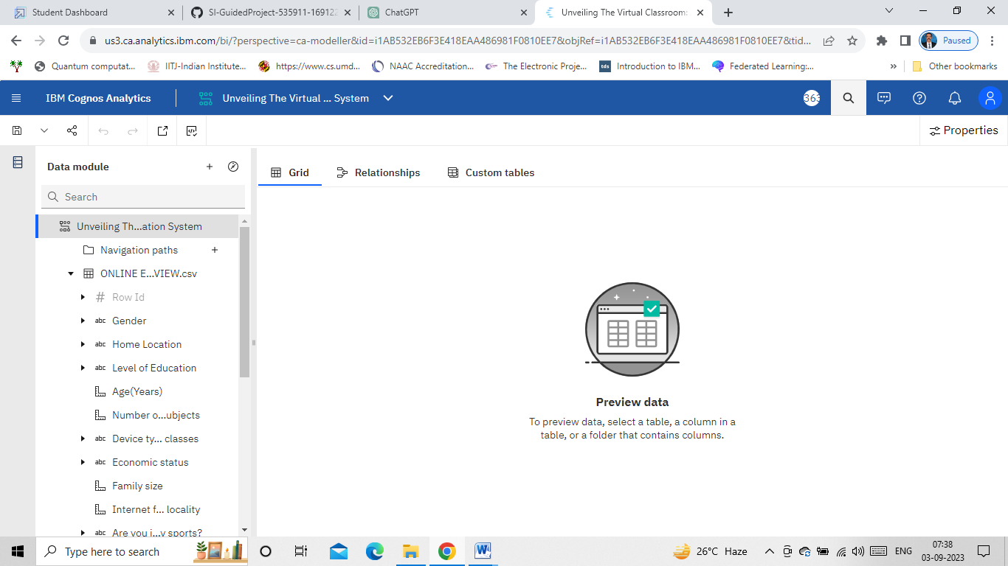

Save the dataset in the “My Content” folder.

* 1. **Prepare the Data for Visualization**

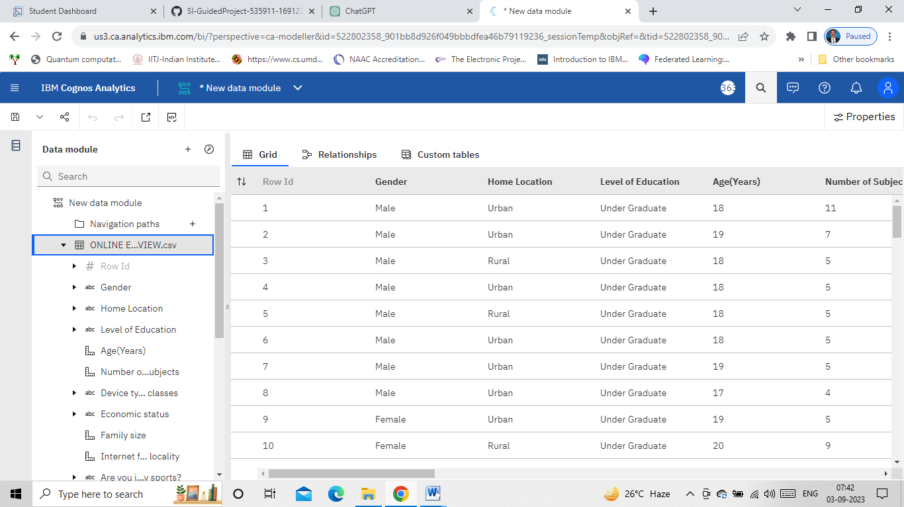

1. **Data Visualizations**

Data visualization is the process of creating graphical representations of data in order to help people understand and explore the information. The goal of data visualization is to make complex data sets more accessible, intuitive, and easier to interpret. By using visual elements such as charts, graphs, and maps, data visualizations can help people quickly identify patterns, trends, and outliers in the data.

* 1. **No of Unique Visualizations**

**Column chart: Age(Years) by Your level of satisfaction in Online Education**

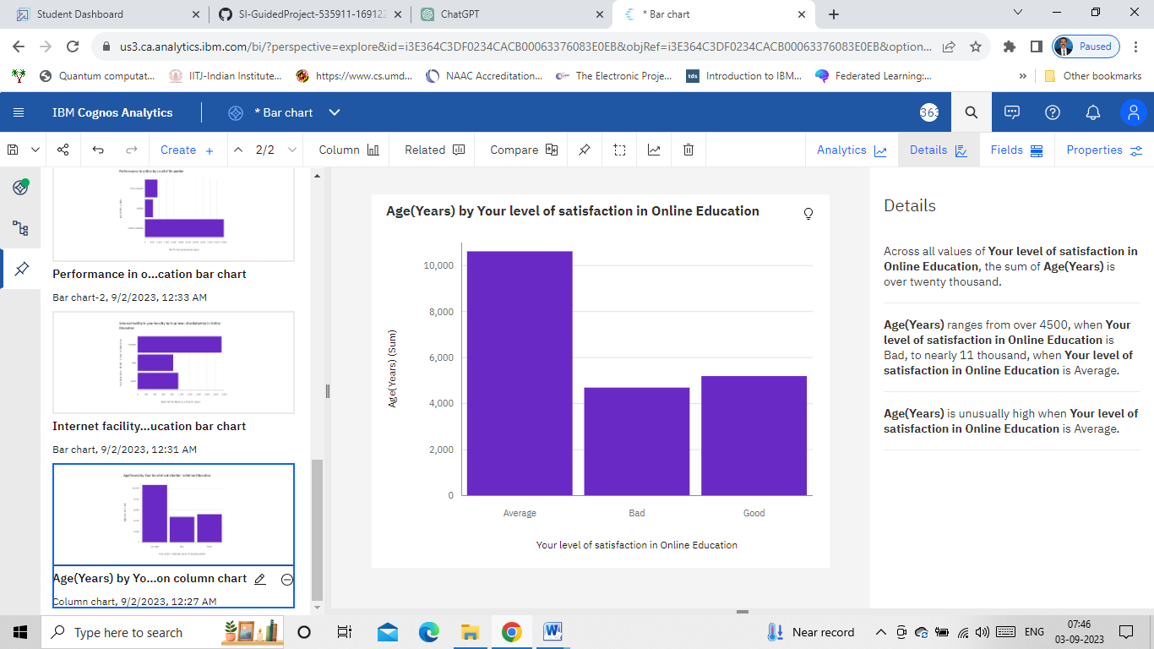

**Bar chart: Internet facility in your locality by Your level of satisfaction in Online Education**

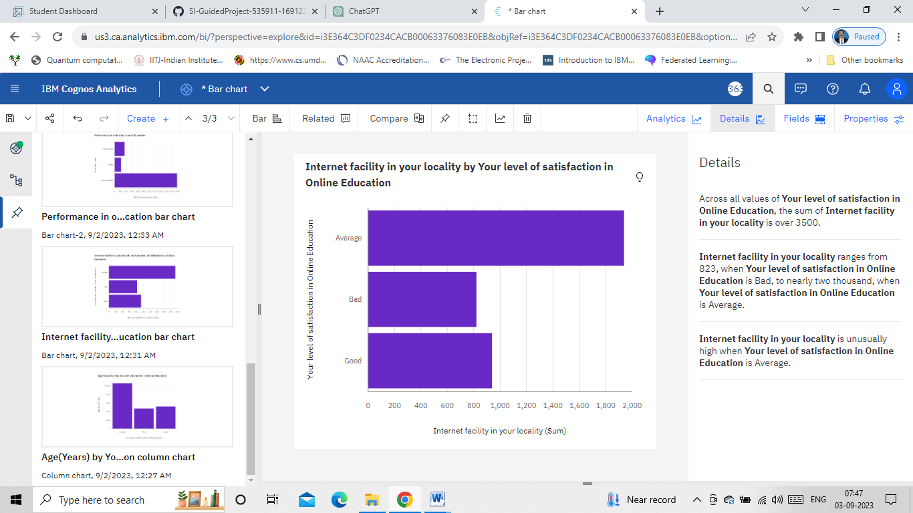

**Bar chart: Performance in online by Level of Education**

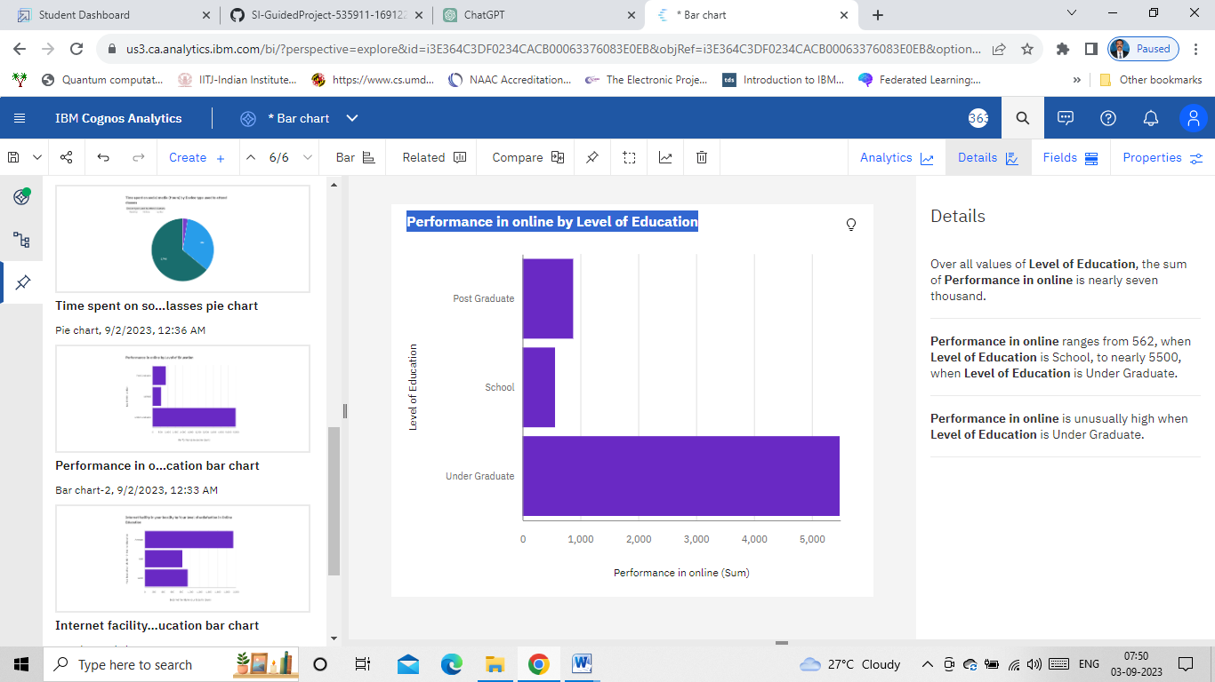

**Pie chart: Time spent on social media (Hours) by Device type used to attend classes**

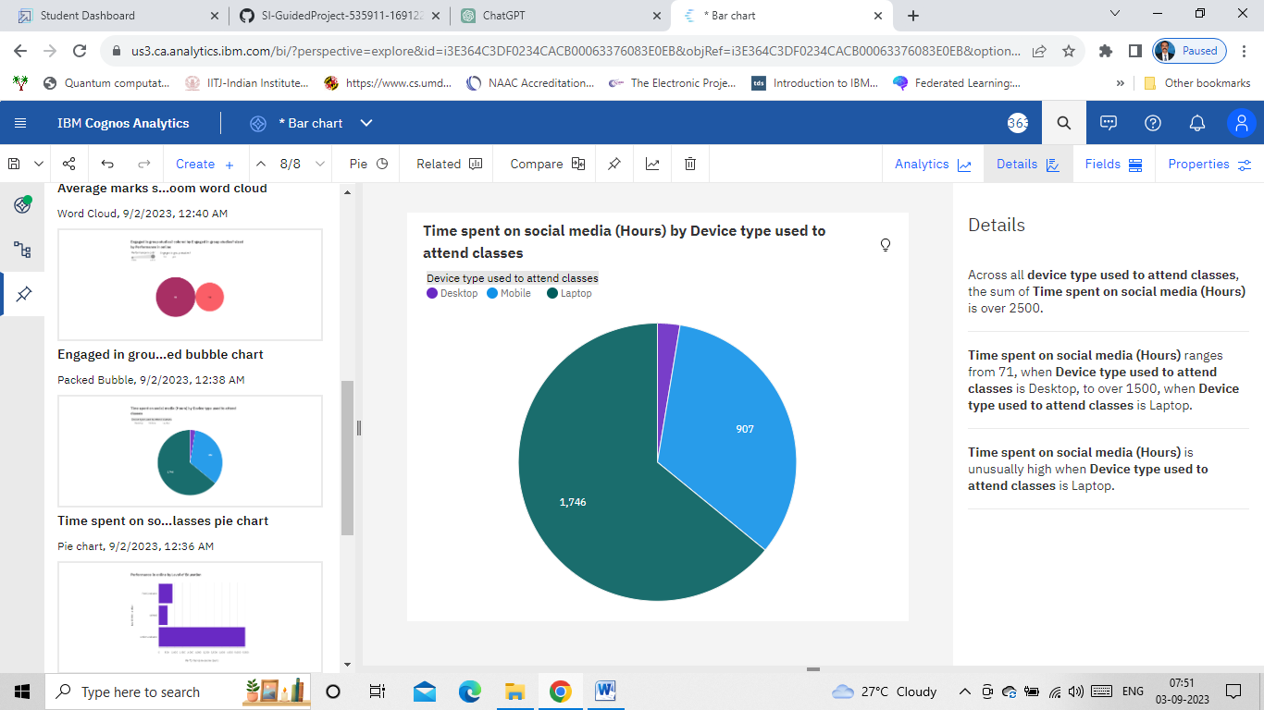

**Packed Bubble: Engaged in group studies? colored by Engaged in group studies? sized by Performance in online**

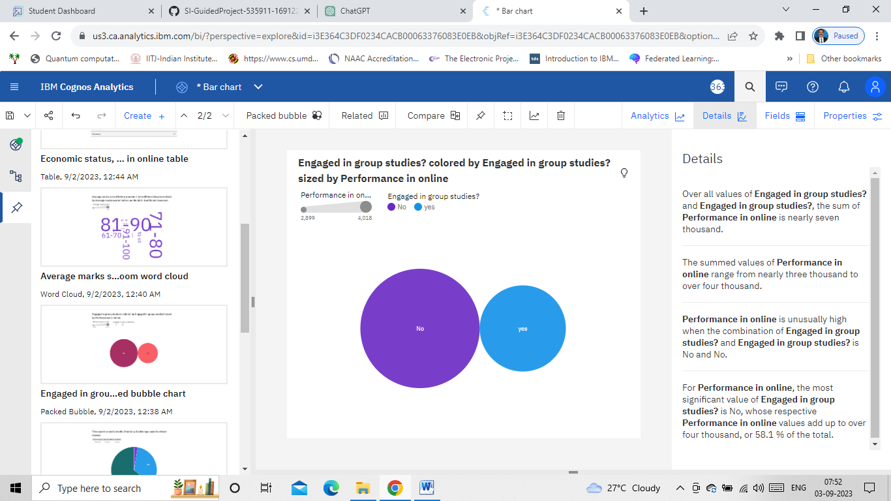

**Word Cloud: Average marks scored before pandemic in traditional classroom sized by Average marks scored before pandemic in traditional classroom**

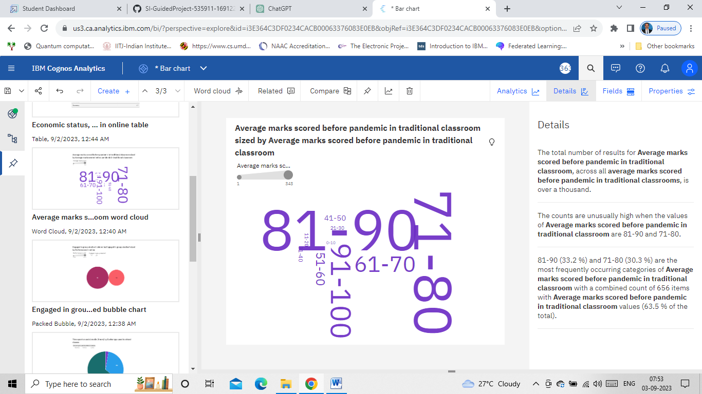

**Table: Economic status, Home Location and Performance in online**

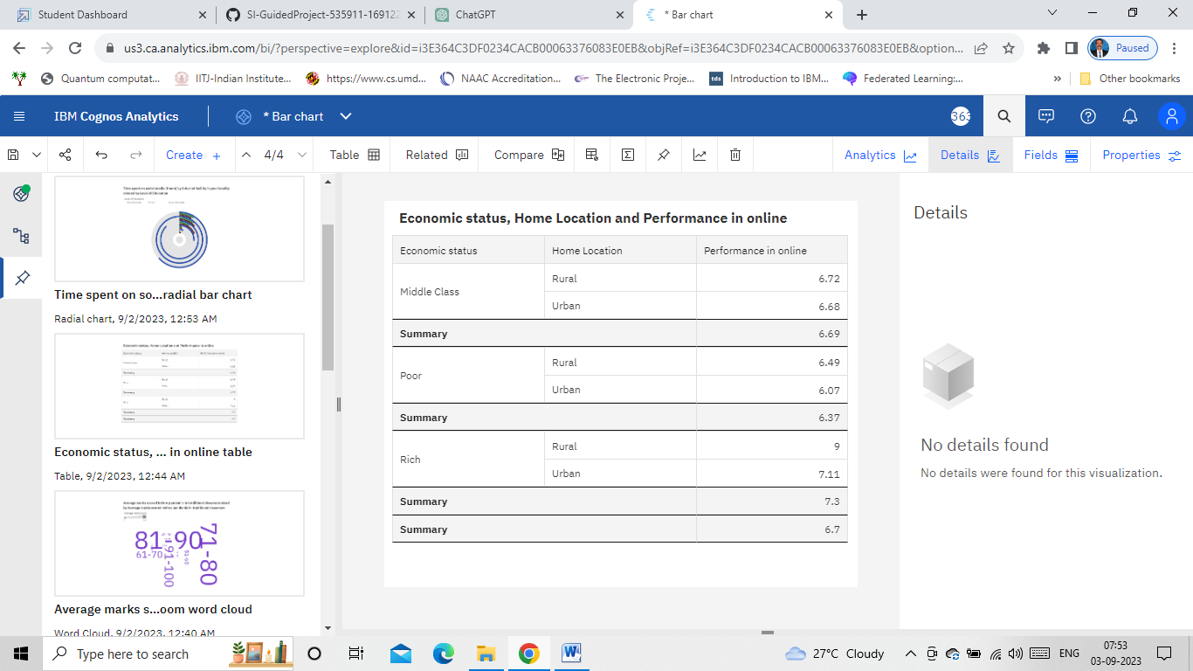

**Radial Bar: Time spent on social media (Hours) by Internet facility in your locality colored by Level of Education**

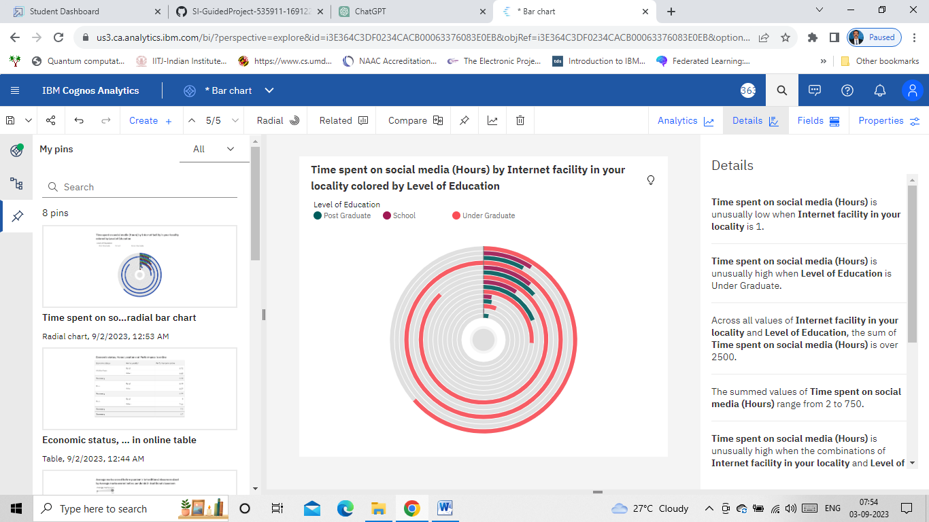

**Line Graph: Performance in online by Study time (Hours)**

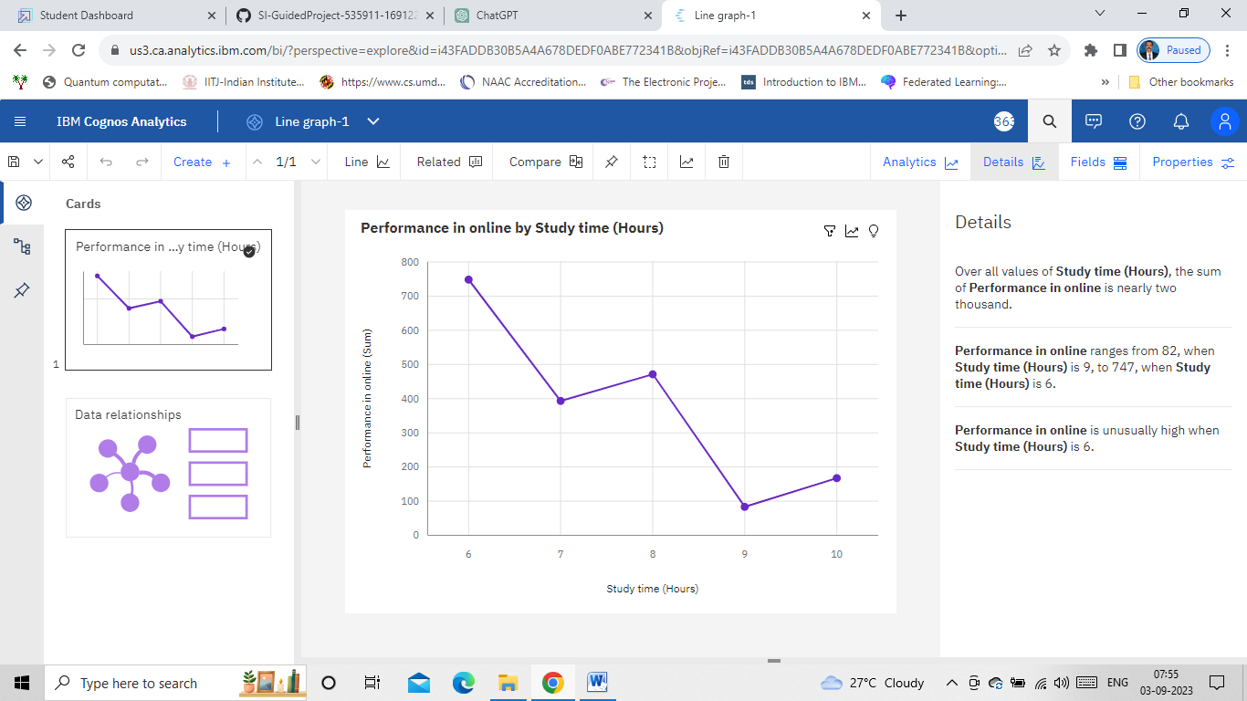

**Line Graph: Sleep time (Hours) by Performance in online**

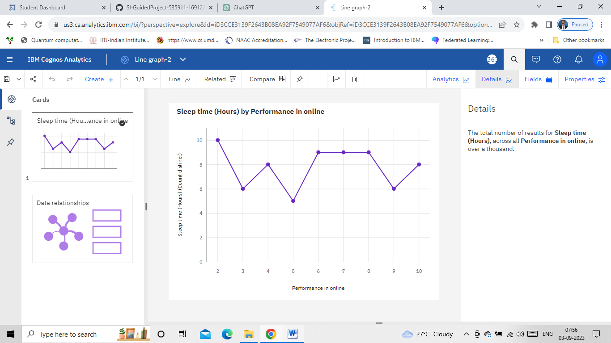

1. **Dashboard**

A dashboard is a graphical user interface (GUI) that displays information and data in an organized, easy-to-read format. Dashboards are often used to provide real-time monitoring and analysis of data, and are typically designed for a specific purpose or use case. Dashboards can be used in a variety of settings, such as business, finance, manufacturing, healthcare, and many other industries. They can be used to track key performance indicators (KPIs), monitor performance metrics, and display data in the form of charts, graphs, and tables.

* 1. **Responsive and Design of Dashboard**

The responsiveness and design of a dashboard for online education review data  is crucial to ensure that the information is easily understandable and actionable. Key considerations for designing a responsive and effective dashboard include  
user-centered design, clear and concise information, interactivity, data-driven approach, accessibility, customization, and security. The goal is to create a dashboard that is user-friendly, interactive, and data-driven.

**Tab-1**

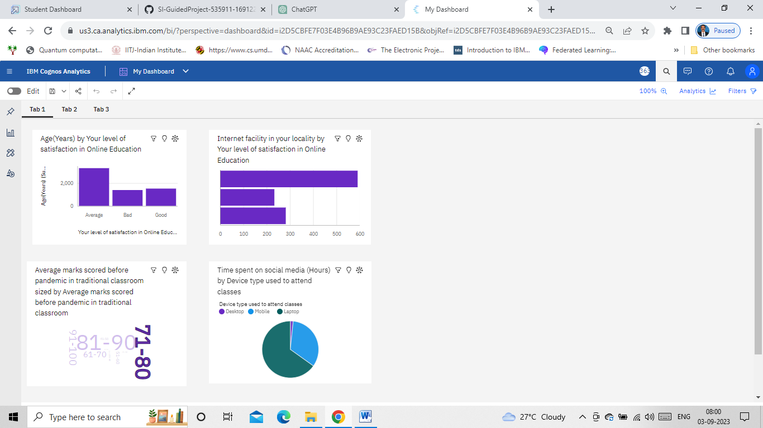

**Tab-2**

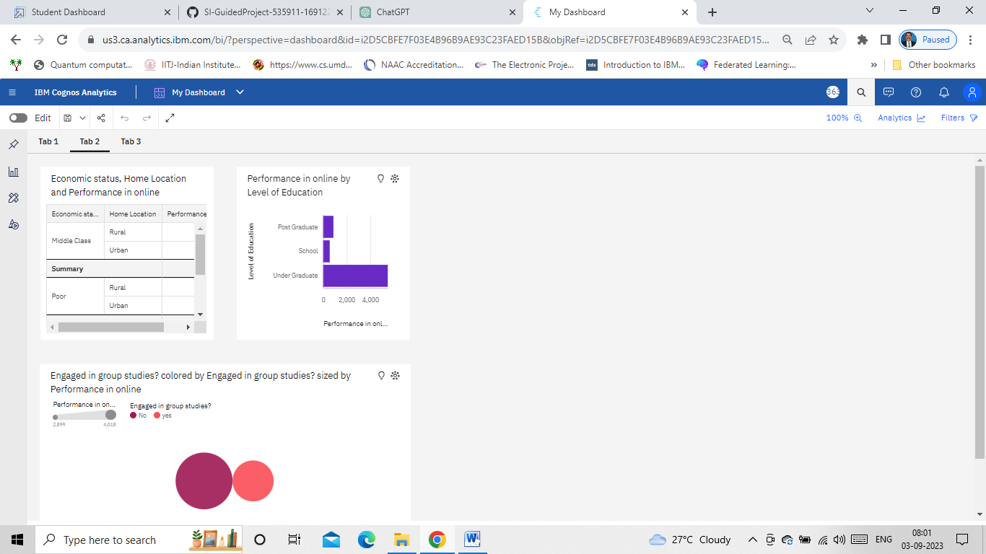

**Tab-3**

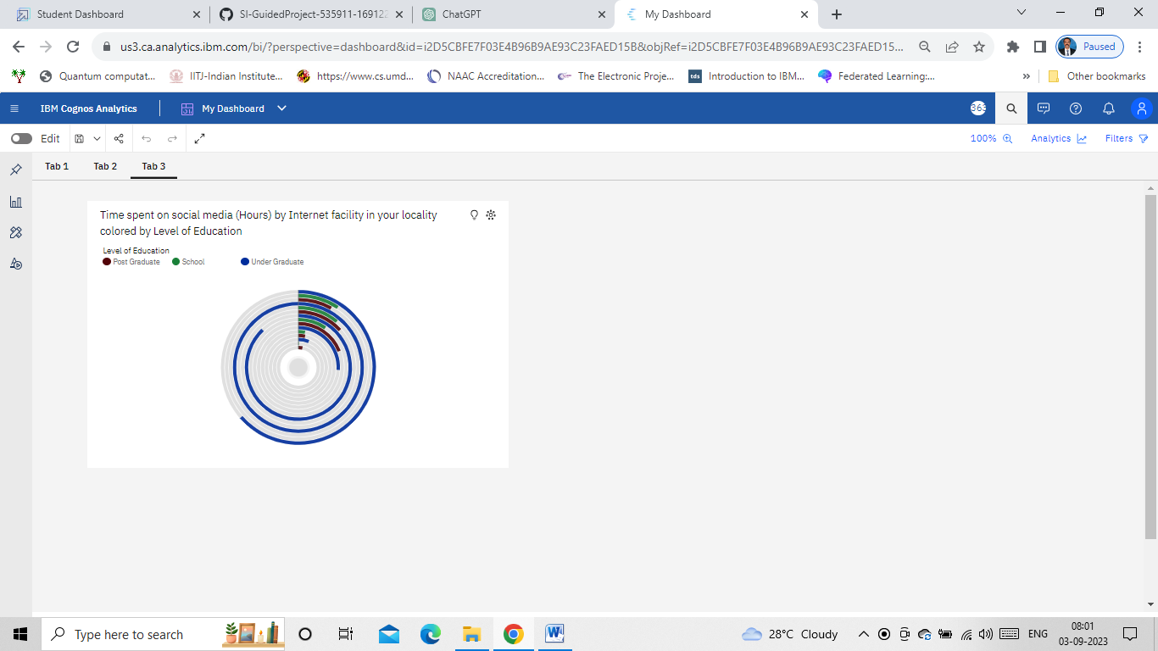

1. **Story**

A data story is a way of presenting data and analysis in a narrative format, with the goal of making the information more engaging and easier to understand. A data story typically includes a clear introduction that sets the stage and explains the context for the data, a body that presents the data and analysis in a logical and systematic way, and a conclusion that summarizes the key findings and highlights their implications. Data stories can be told using a variety of mediums, such as reports, presentations, interactive visualizations, and videos.

* 1. **No of Scenes of Story**

The number of scenes in a storyboard for a data visualization analysis of the performance and efficiency of online education will depend on the complexity of the analysis and the specific insights that are trying to be conveyed. A storyboard is a visual representation of the data analysis process and it breaks down the analysis into a series of steps or scenes.

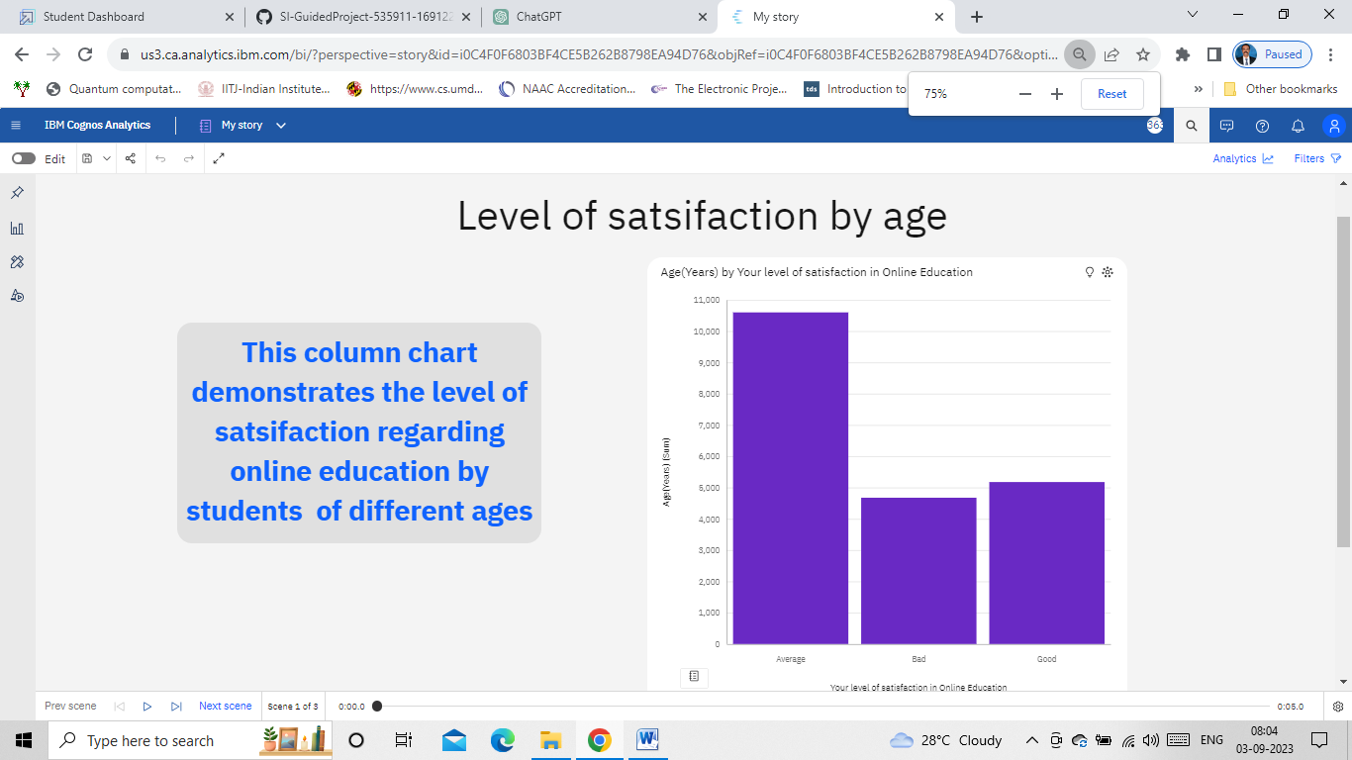

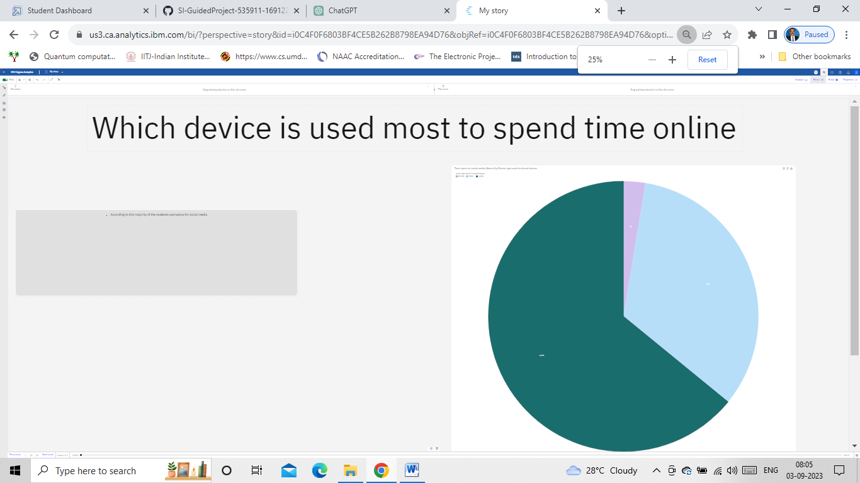

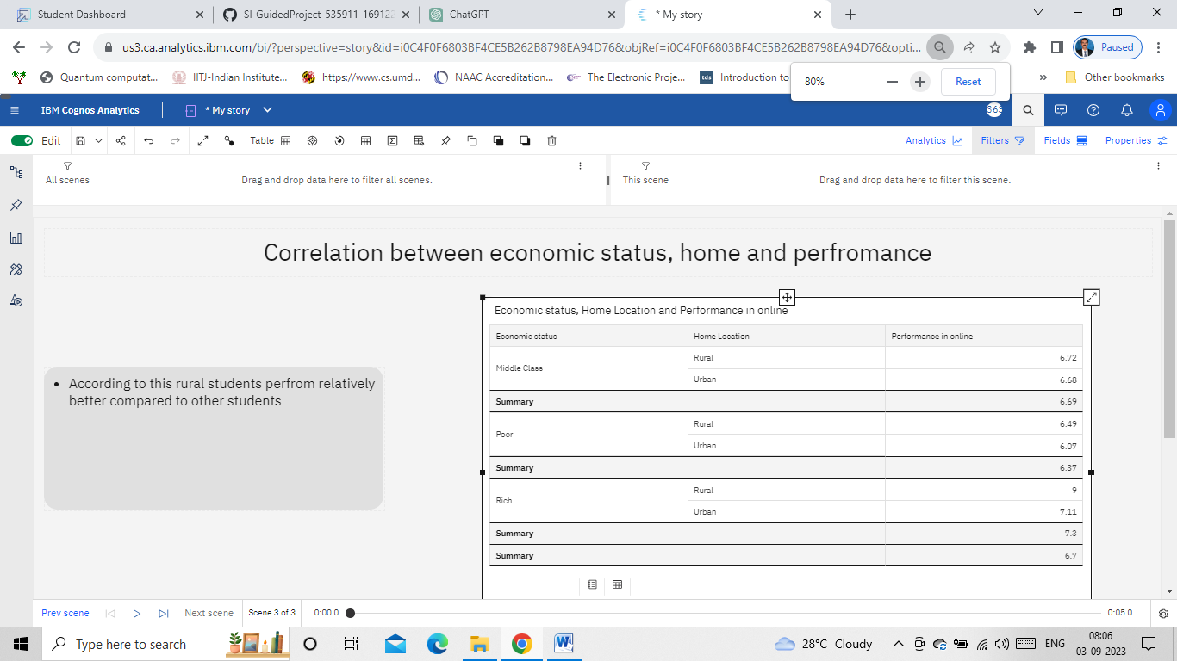

1. **Report**

A report is a document that presents information in a specific format and layout, usually based on data from a database or other data source. A report in IBM Cognos can contain various elements, such as tables, charts, graphs, and images, as well as text and data elements, and it is designed to be used by business users to help them better understand their data and make informed decisions. There are several different types of reports available in IBM Cognos, including list reports, crosstab reports, chart reports, and report studio reports, among others. The type of report that you choose will depend on the specific needs and requirements of your organization, as well as the data that you need to present.

* 1. **Creating a report**







1. **Performance Testing**

Performance testing is a non-functional software testing technique that determines how the stability, speed, scalability, and responsiveness of an application holds up under a given workload.

* 1. **Amount of Data Rendered to DB**

The data mounted consists of 1033 instances with 23 attributes.

* 1. **Utilization of Data Filters**
* Data filters are used to customize our visualization to achieve desired output
* We can apply filters while building visualizations . In explorations, filters are present at bottom of the ‘Fields’ option

**Pie Chart**

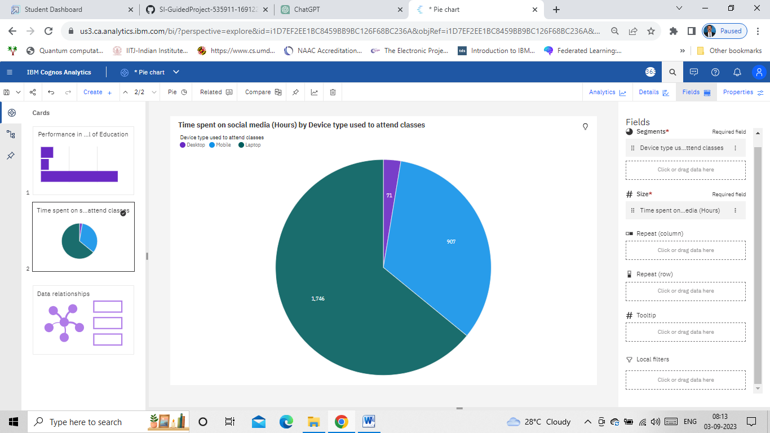

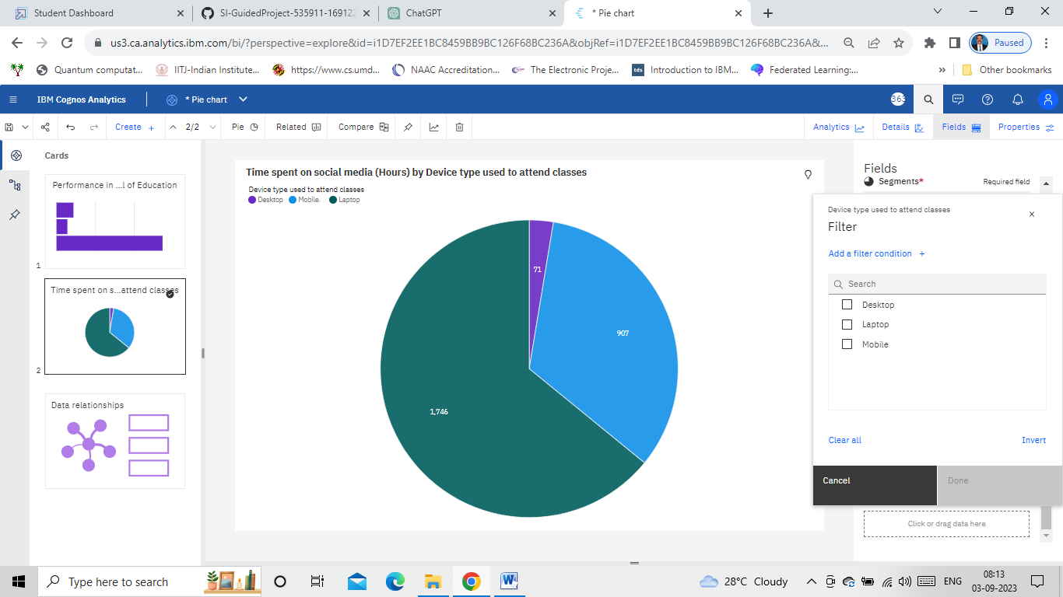

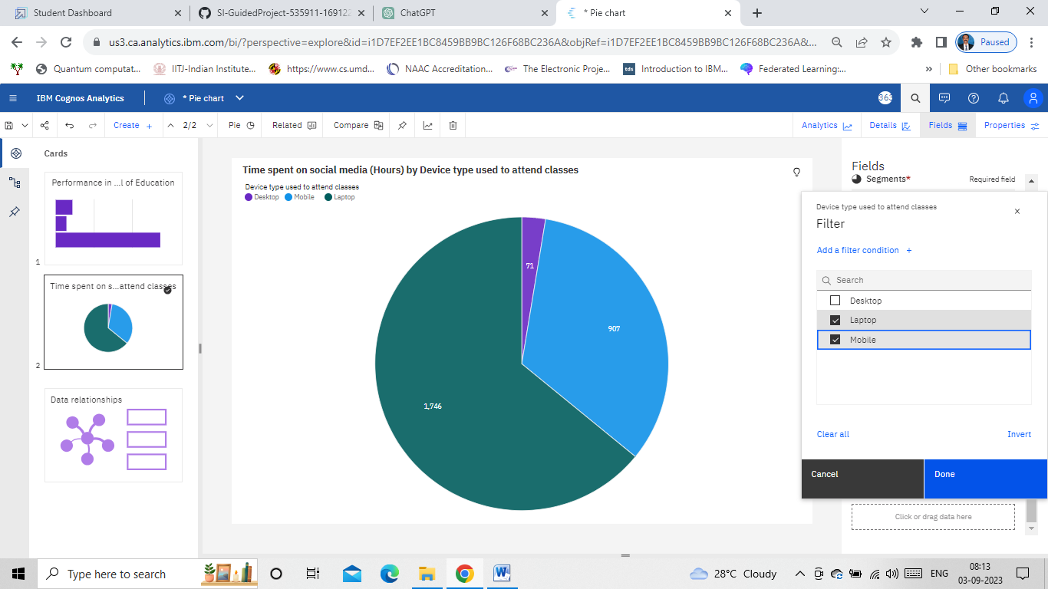

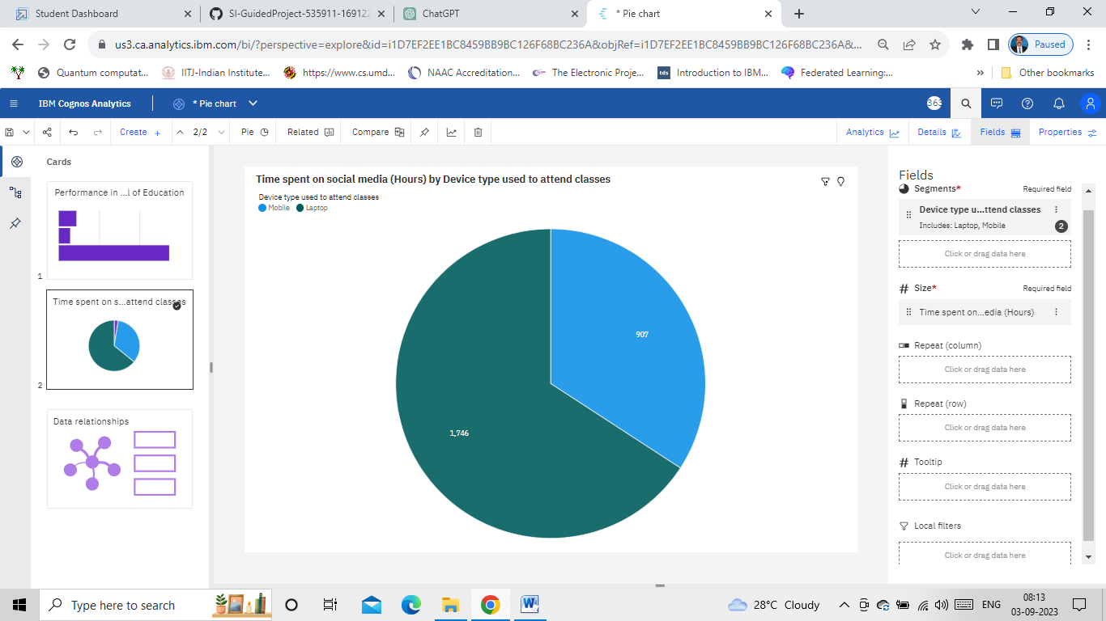

**Table**

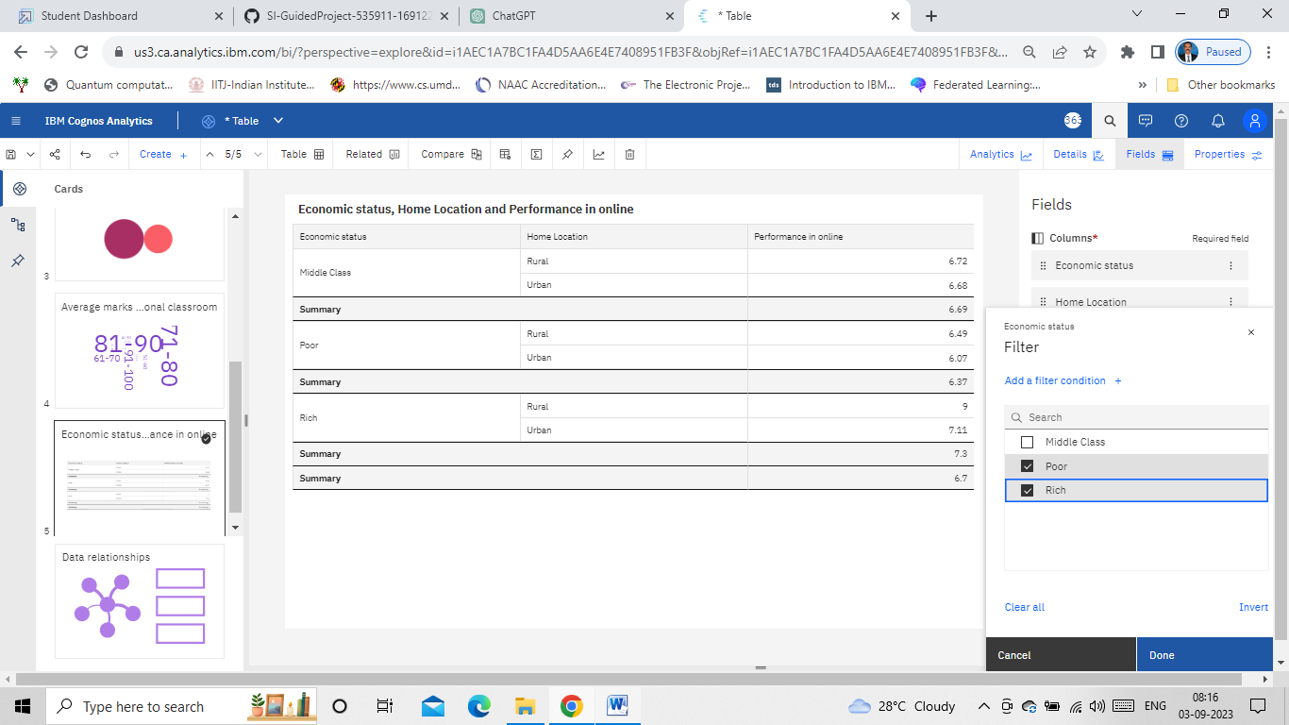

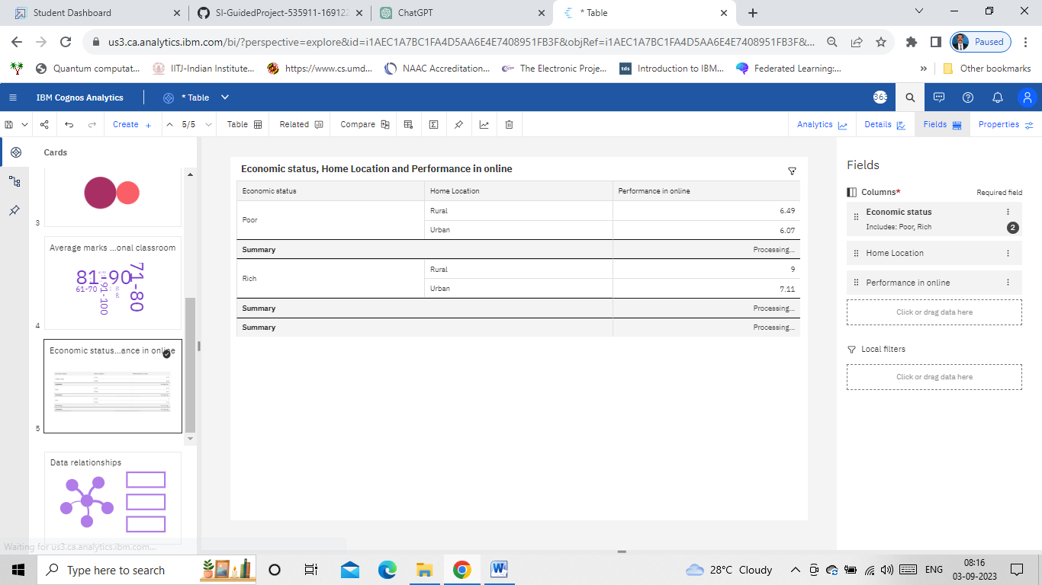

* 1. **No of Calculation Fields**

Click on the “three dots” beside the field which results in the following:

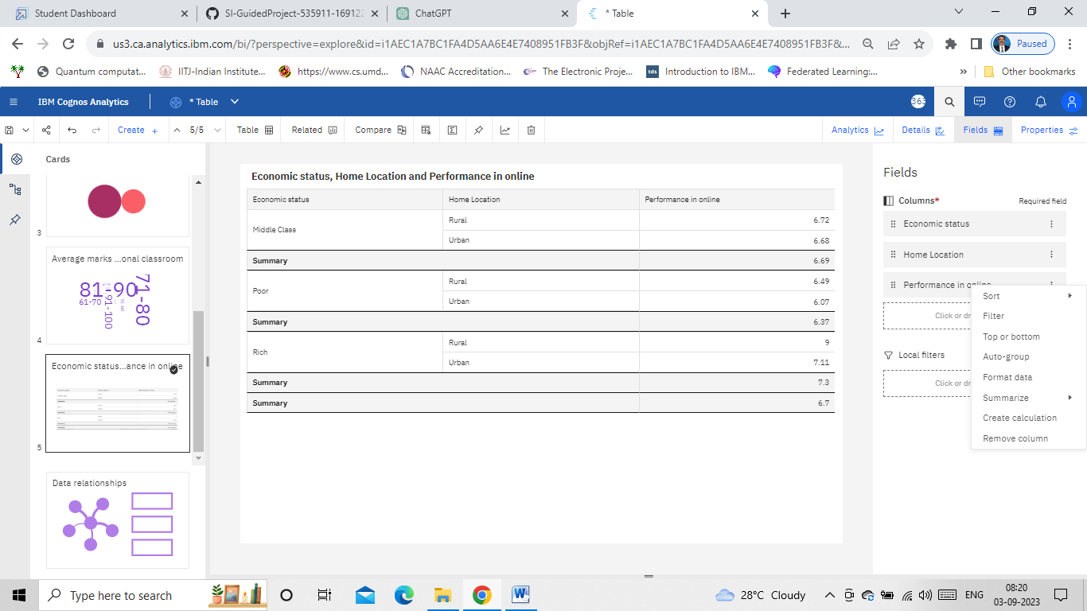

Click on summarize and choose “Average”.

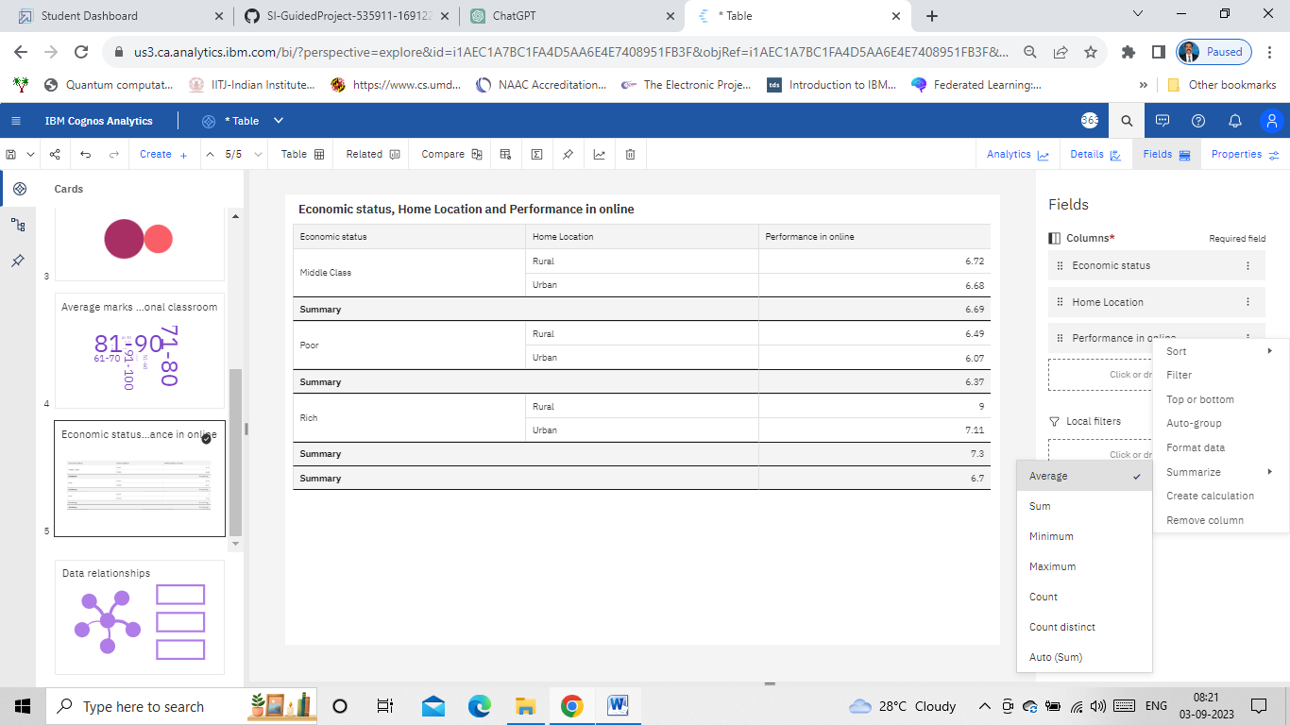

Click on summarize and choose “Sum”.

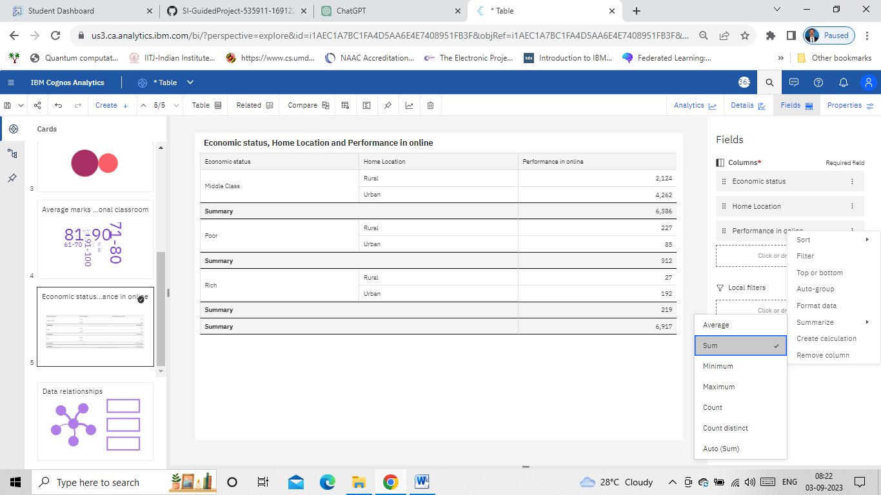

* 1. **No of Visualizations/ Graphs**

The following charts have been created and have been included as part of data visualization. Please refer to “Data Visualization” section.

* Column Chart: Age(Years) by Your level of satisfaction in Online Education
* Bar Chart: Internet facility in your locality by Your level of satisfaction in Online Education
* Bar chart: Performance in online by Level of Education
* Pie Chart: Time spent on social media (Hours) by Device type used to attend classes
* Packed bubbles : Engaged in group studies? colored by Engaged in group studies? sized by Performance in online
* Wordcloud: Average marks scored before pandemic in traditional classroom
* Table: Economic status, Home Location and Performance in online
* Radial Chart:
* Line Chart: Performance in online by study time(hours)
* Line Chart: Performance in online by sleep time(hours)

1. **Web Integration**

Publishing helps us to track and monitor key performance metrics, to communicate results and progress. help a publisher stay informed, make better decisions, and communicate their performance to others.

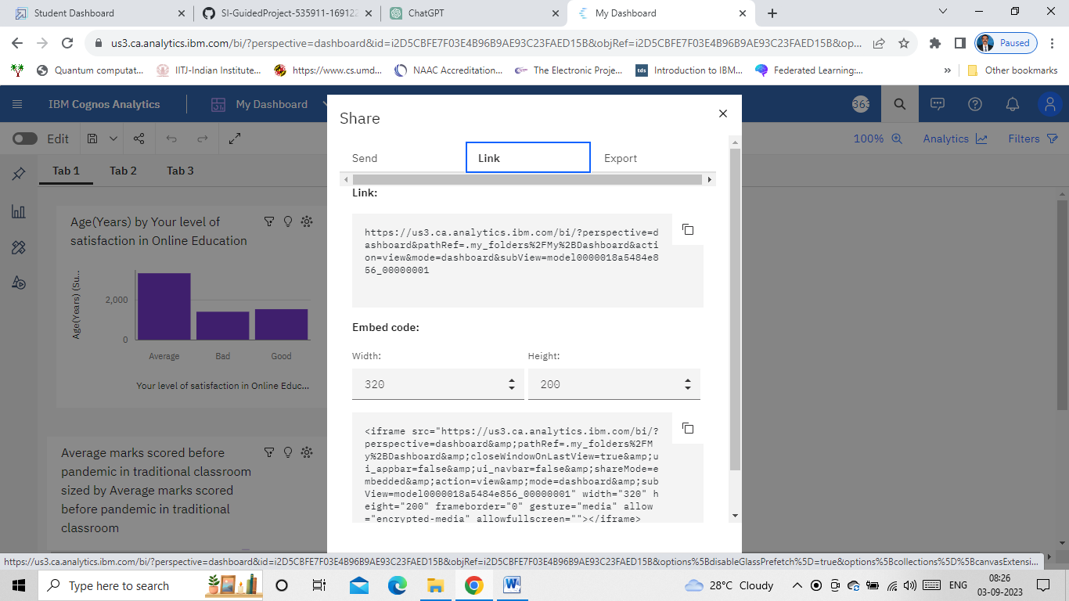

* 1. **Dashboard and Story embed with UI With Flask**

To embed the story, dashboard and the report with UI with Flask, the following steps are followed:

Step-1: Download the free online Bootstrap templates that suits our requirement

Step-2: Install Visual Studio Code

Step-3: Open the “index.html” file in visual studio code

Step-4: Locate “about”, “prtofolio” and “services” and remove the content present between the tags “div”. Insert the corresponding the content copied from the cognos share option of dashboard, story, and report respectively. Modify the width and height to 1100 and 1000 respectively.

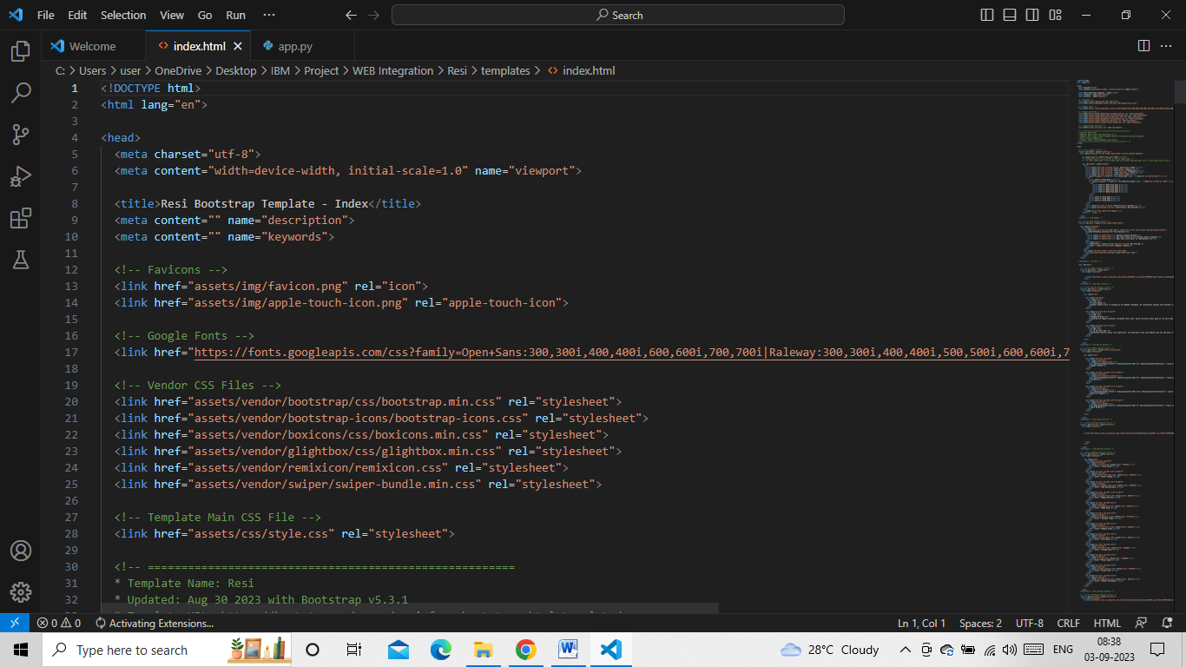

Step-5: Install “Flask” using pip install flask

Step-6: Create the “app.py” file as follows in visual studio code

from flask import Flask, render_template

app = Flask(__name__)

@app.route("/")

def home():

return render_template(r"index.html")

if __name__ == "__main__":

app.run(debug=False, port=5000)

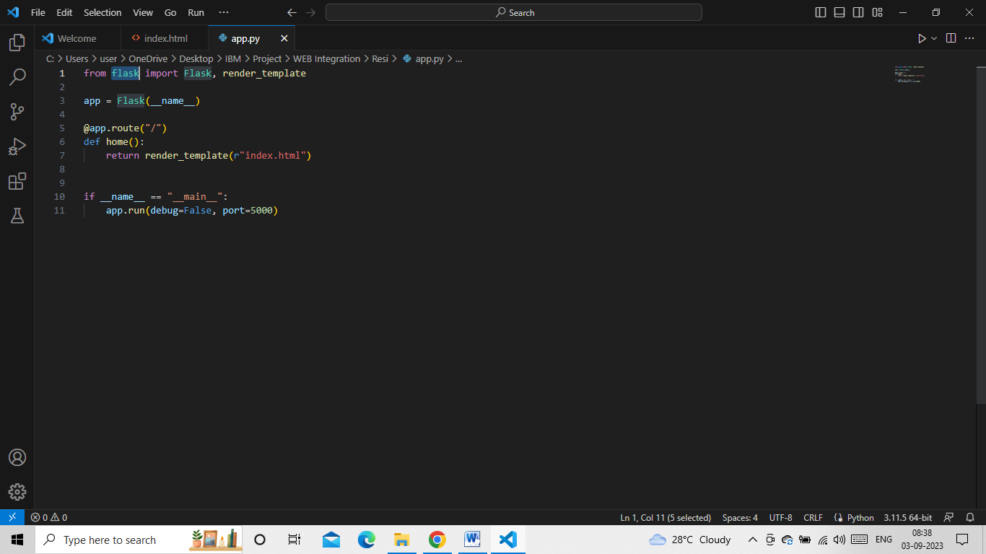

Step-7: Run the python file which the provides the following address

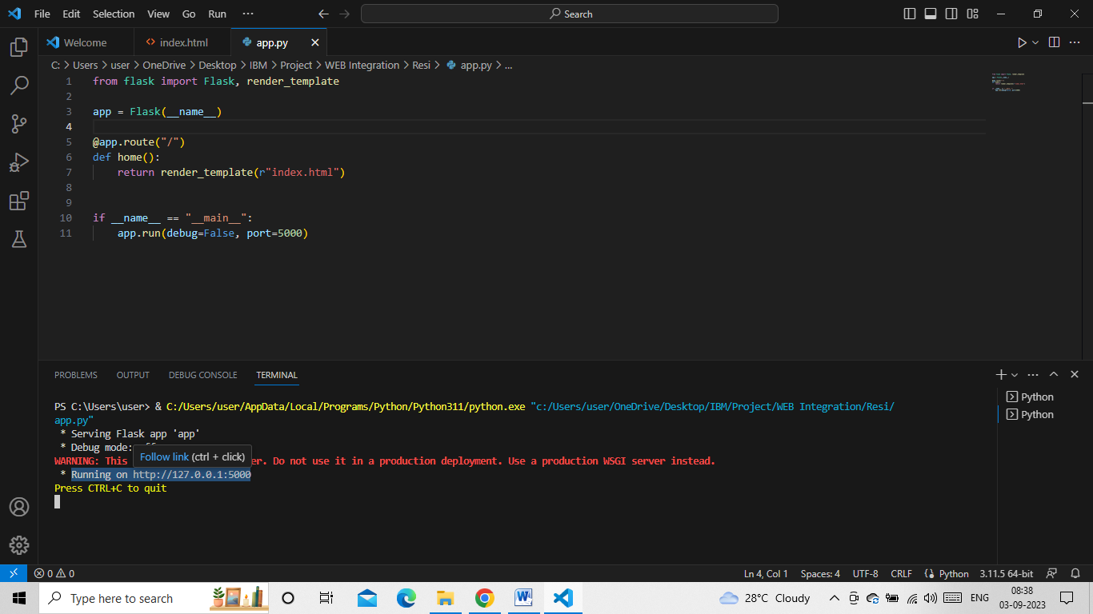

Step-8: Copy the address: <http://127.0.0.1:5000> and paste it in address bar and run

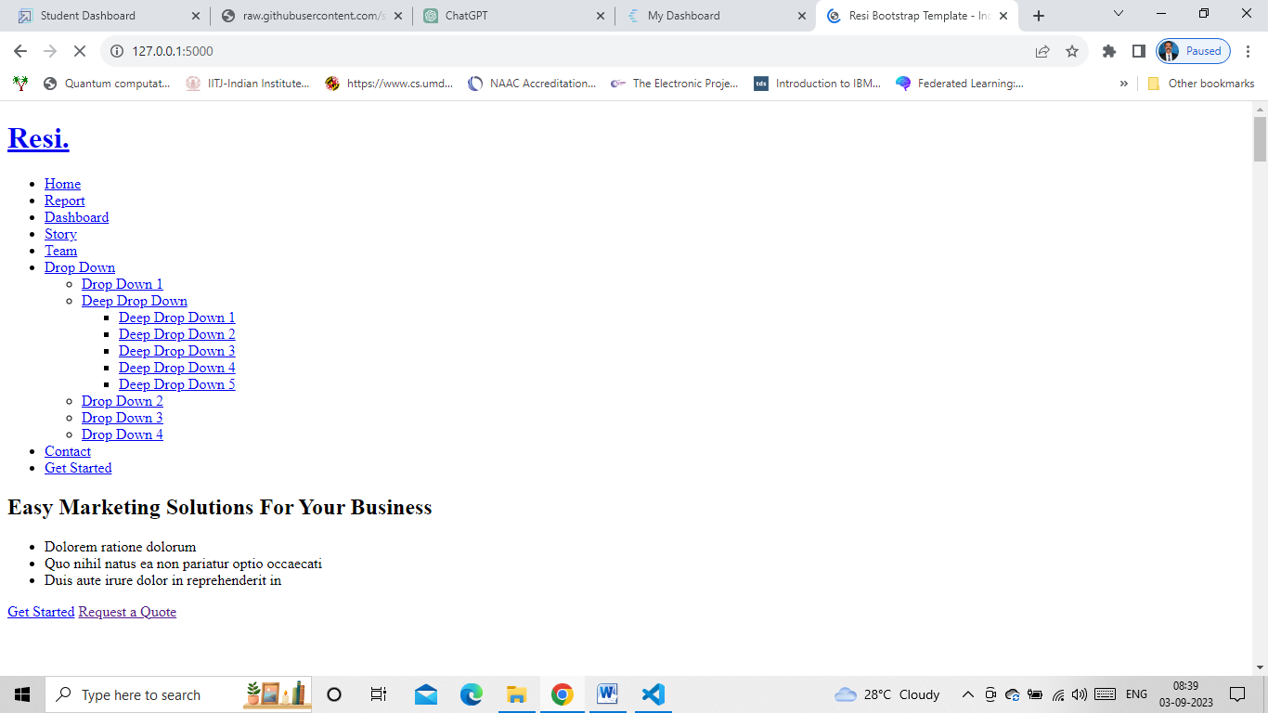

1. **References**

* Allen, I. E., & Seaman, J. (2017). Grade Increase: Tracking Distance Education in the United States.
* Means, B., Toyama, Y., Murphy, R., Bakia, M., & Jones, K. (2009). Evaluation of evidence-based practices in online learning: A meta-analysis and review of online learning studies.
* Anderson, T. (2003). Getting the mix right again: An updated and theoretical rationale for interaction.
* Lee, Y.-H., Hsieh, Y.-C., & Hsu, C.-N. (2014). Adding innovation diffusion theory to the technology acceptance model: Supporting employees’ intentions to use e-learning systems.
* Hodges, C., Moore, S., Lockee, B., Trust, T., & Bond, A. (2020). The difference between emergency remote teaching and online learning.
* DiMaggio, P., Hargittai, E., Neuman, W. R., & Robinson, J. P. (2001). Social implications of the Internet.
* Garrison, D. R., & Kanuka, H. (2004). Blended learning: Uncovering its transformative potential in higher education.
* Bergmann, J., & Sams, A. (2012). Flip your classroom: Reach every student in every class every day.